|  |  |
| --- | --- |
| Name: | Alex Orr |
| Company: | 50music |
| Contact details: | alexander.orr@mail.bcu.ac.uk // jackpedersen@mail.bcu.ac.uk |

B r I e f & C O N T E N T :

50music is an online application service aimed at low to mid-level bands looking to apply to perform at music festivals across the country. The application will involve the customer paying a flat rate for us to apply to 50 music festivals on their behalf for the summer of 2016. The 50 festivals will be taken from our festival database, which includes over 100 British music festivals. The particular customer’s style, genre and size will be the criteria by which we will select the festivals to apply for on their behalf. We are targeting rock bands with this service – ranging across several sub-genres such as indie rock, metal, punk rock and hard rock, although we have potential to expand to more genres if we find adequate success over time.

50music is running as a beta test for a paid service currently – we are working on refining the process of application to create an extremely convenient and user friendly service. To do this we are asking bands to essentially go through the process as if it were a real transaction. We are looking for a web developer to design and build this website.

We want the front page of the website to be simple – give information on the service succinctly whilst being aesthetically appealing. Whilst we don’t have any social media presence yet we will want this to be integrated – a simple sidebar and links would suffice.

Front Page

Hello! Welcome to 50Music. We are an online festival application service aiming to help artists and bands save time and effort in the festival application process by doing all the busy work for you!

50Music is very easy to use. All you have to do is head over to the packages page and browse through our various offers until you find one you feel is right for you and/or your band.

When you’ve picked, you will be taken to a form page where you will help us learn everything about your band. Genre, best songs, social media following, we want to know everything to make sure your applications have the best possible chance of success.

From there, we use that information with our database of British music festivals to pick the 50 most relevant festivals to you. Then it’s simple – we apply to them on your behalf!

We would also like an ‘about’ page. This will be very simple, essentially acting as a little fact file on myself and Jack, the creators.

About 50Music Page

Alex Orr – Alex is a 20 year old who started 50Music because he loves festivals and he loves music. He saw a gap in the market for this style of service due to the sheer number of local to national festivals across the country. Having worked at over 50 festivals, he found that many of the smaller shows that still drew audiences were simply not being applied to by lower-level bands. With 50Music, he looks to change that by providing a simple way for bands to apply to music festivals quickly and efficiently.

Jack Pedersen – Jack is a 20 year old who has worked with hundreds of bands in a professional capacity through his job as a recording engineer. Having played in several bands, he knows what younger artists and bands are looking for – exposure, and looks to use the country’s massive variety of music festivals to help them get this.

We will also need a disclaimer page. We want this simple – literally just the text is fine.

Disclaimer Page

50Music does not provide liability insurance for the protection of individuals, groups, organizations, businesses, spectators or others who may perform or work at a festival in which the application was processed through this website.

50Music does not guarantee that using the service will ensure you (the client) will play at a festival. Whilst we apply for clients to play at music festivals, it is ultimately the festival’s production team that makes the decision whether to accept the application or not.

The logos, images and written content found within this website is subject to copyright and may not be reproduced without express written consent of the author.

Finally, there are the packages and application page – the page customers would go to if they were interested in using our service:

Package Page

This page will be a list of the various packages we sell (although during the beta test there will be only one package available). We would like this page to have an dummy image (for now) with the words ‘50Music Rock Package’ underneath. Clicking on this image will take you to a new page which will have the following information (and a dummy image). After the text we would like a button to take them to the application page.

The 50Music Rock Package is our most basic package – no frills or extras, we simply apply to 50 rock-based music festivals on your behalf using our database in conjunction with information about your band.

Application Page

This page will work as a contact form essentially – we will need the following information.

Name

Band Name

Members

Package

Genre

Links to band’s social media accounts

Links to band’s music

EPK

Upon acceptance of the brief we can discuss in more detail what will be needed for this, but on a basic level this is what we are looking for.

Colour Scheme/Logos

We are currently in the process of having our logo and image designed. It is mostly done, there are just a few more logistic issues we are taking care of. For your reference, this is the logo:

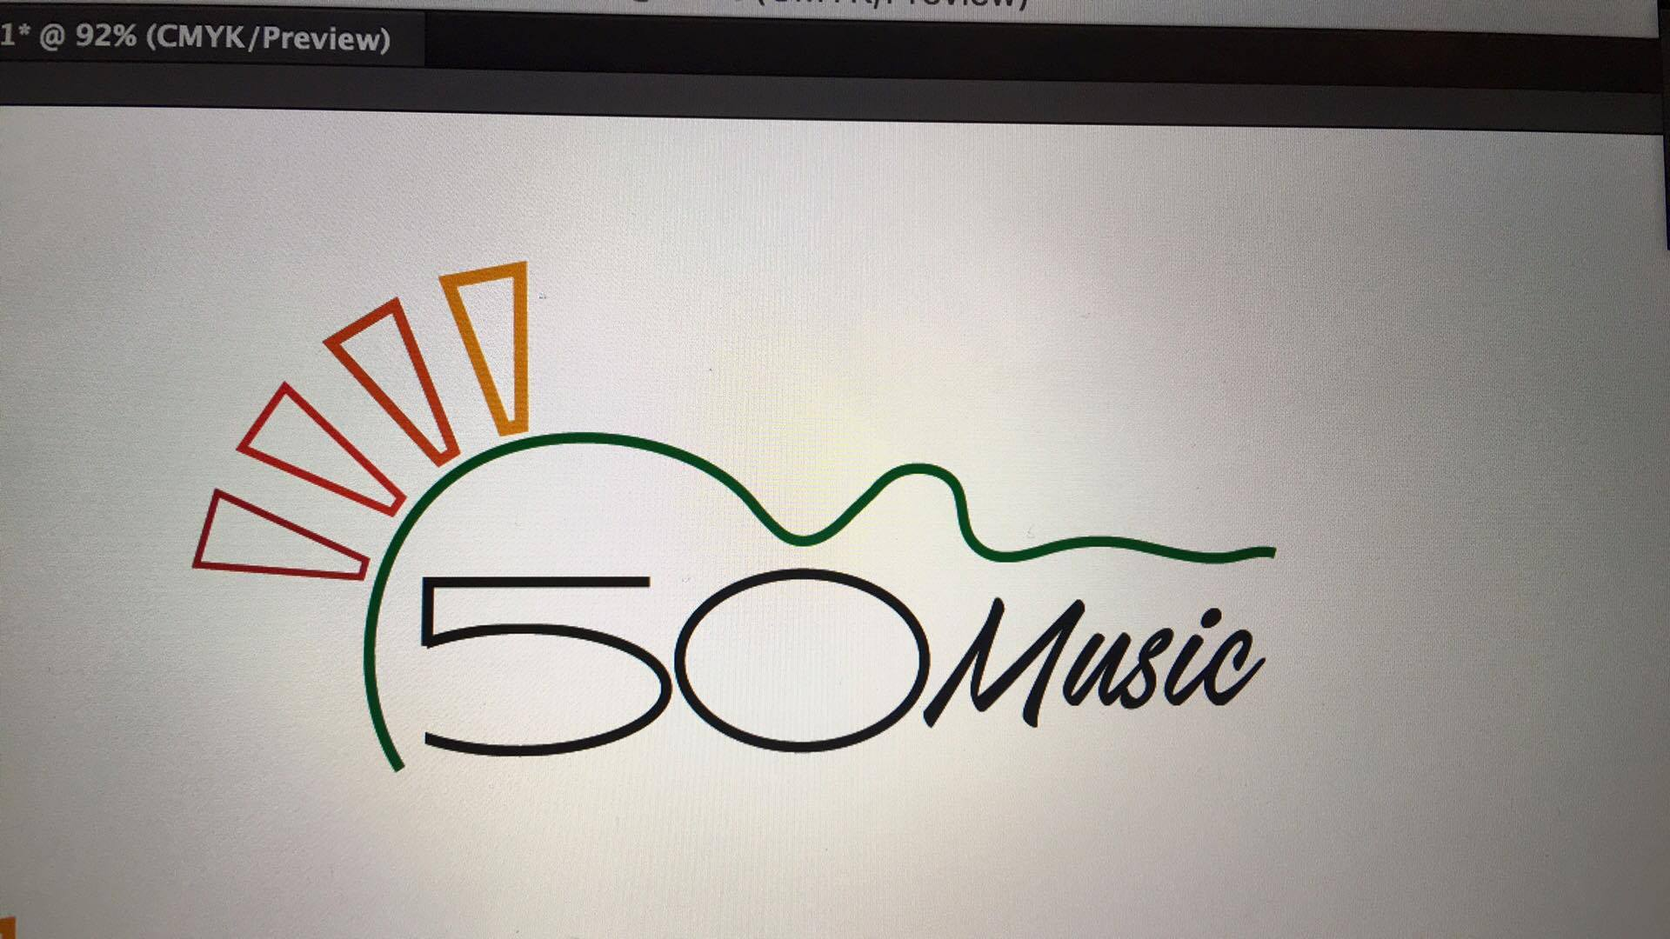

And this is the banner version. We would like this to go along the top of the website above or possibly as the top bar (Links to different pages etc.)

